Raw Milk Collection to Plant Reception

1. Workflow Overview
The workflow follows raw milk from the shops on a route, through ZMCC reception and dispatch, to the plant gate and silo. It has four stages:
- Stage 1 – Area Milk Collection
- Stage 2 – HC/MC Reception at ZMCC
- Stage 3 – ZMCC/Contractor Dispatch to Plant
- Stage 4 – Plant Reception
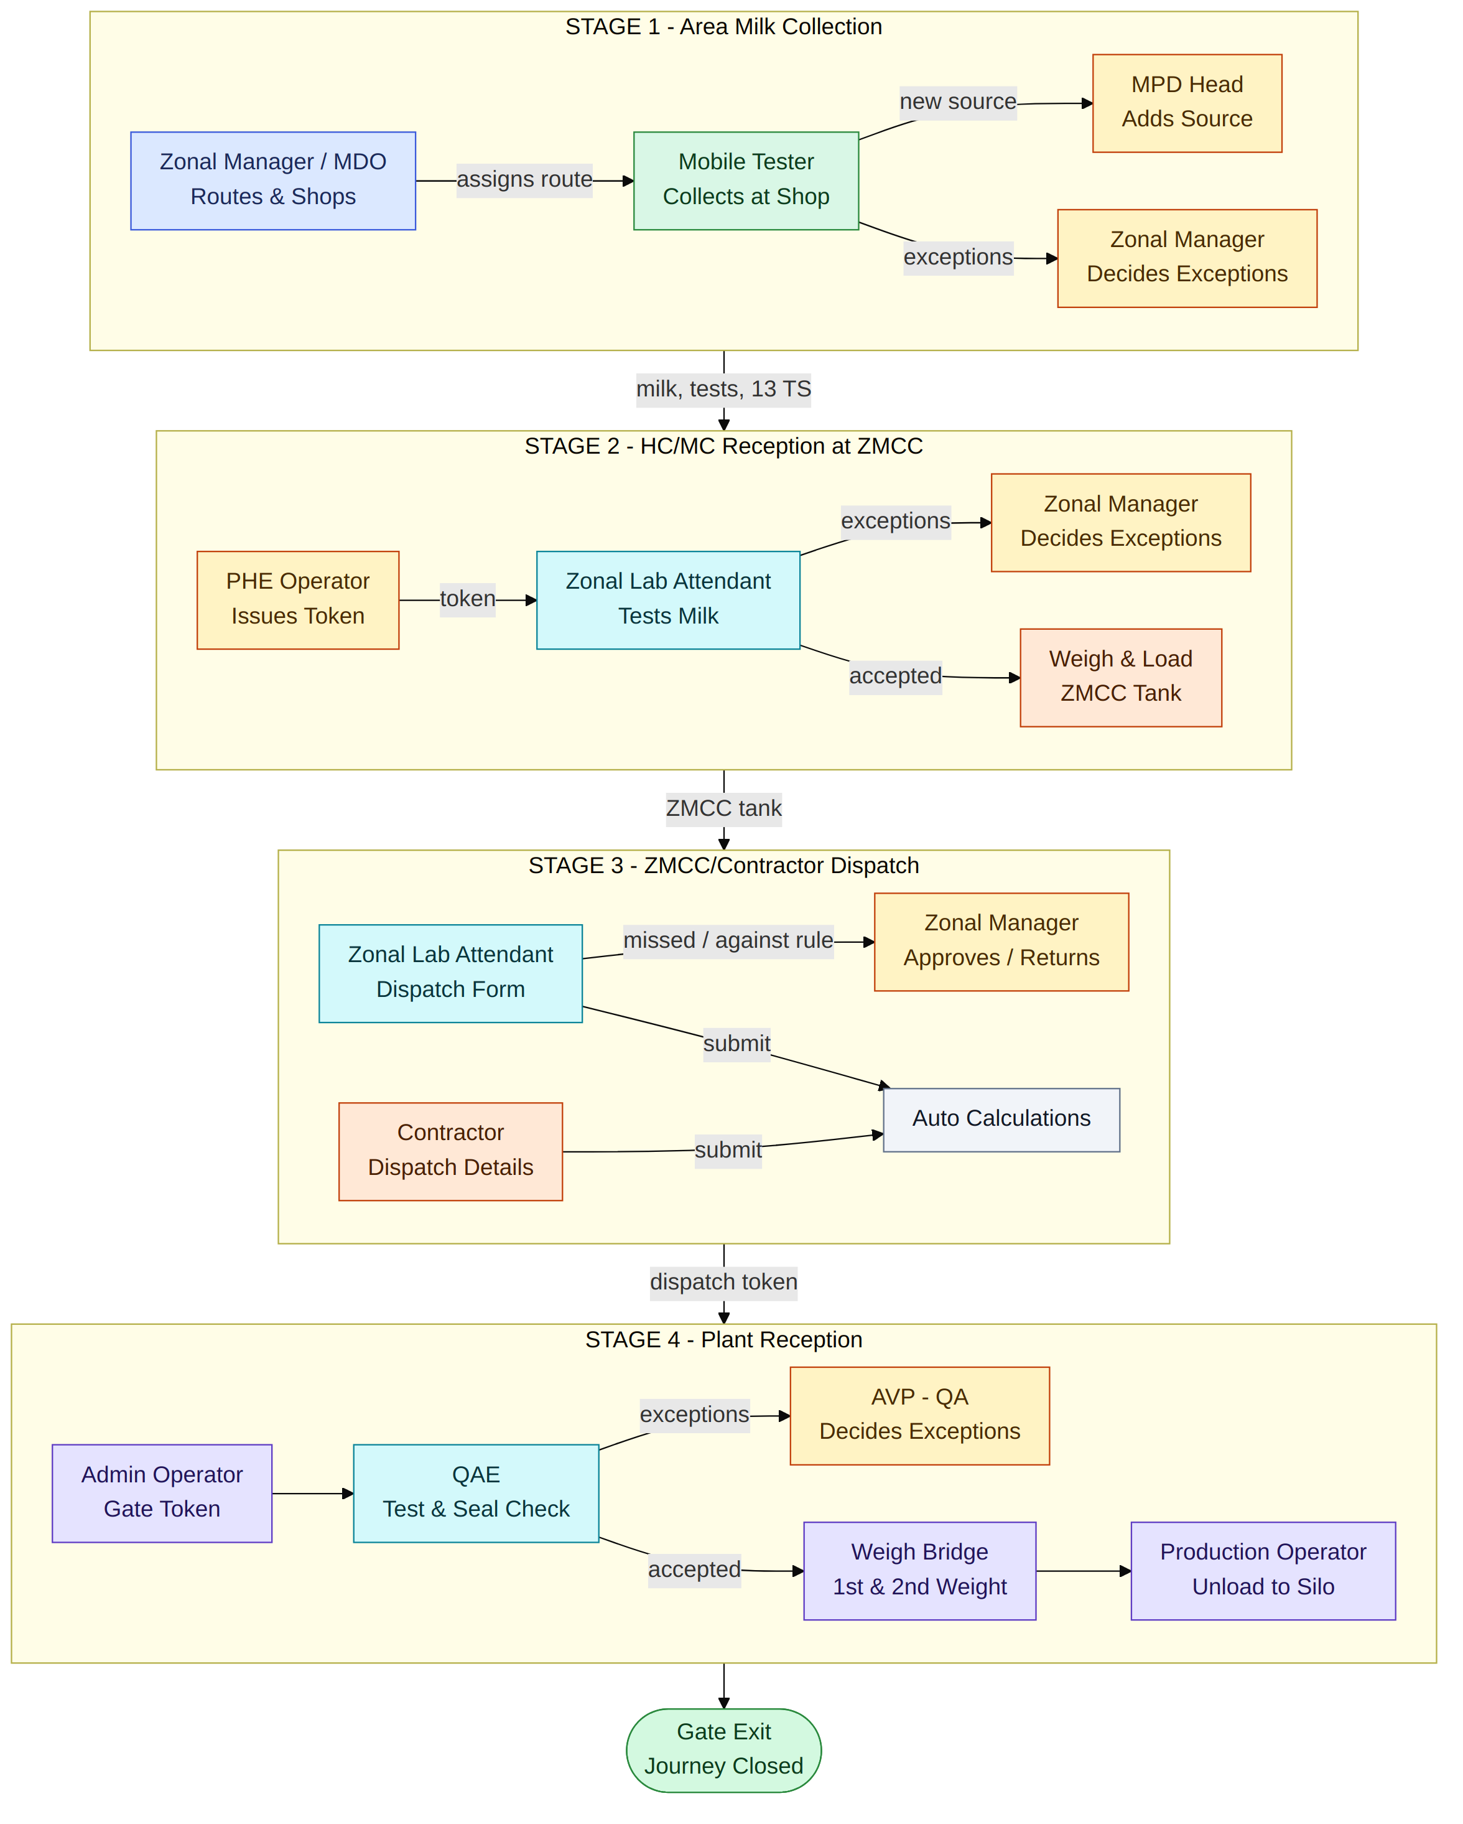
Figure 1: Users and stage hand-offs

2. Users and Their Actions
User / role | Actions in the workflow | Stage
PHE Operator | Issues the Raw Milk Token at PHE. | 2
MDO (Milk Development Officer) | Creates routes (Route, Current Route list, Add New Route) and assigns a route to the Mobile Tester. Adds new shops on request. | 1
Mobile Tester (MOT) | Works on the assigned route shop by shop. Records the Raw Milk Reception Token, gross liters, source, and the assigned test with a picture. Submits (shop close), then moves to the next shop or returns to PHE. | 1
Zonal Manager | Adds routes, assigns routes to the Mobile Tester and adds shops (Route, Current Route List, Add New Route). Approves routes added by the MDO and new HC information. Decides on shop exceptions: OKAY with remarks, or NO with remarks (Shop Rejected). In Stage 2, decides on exceptions: OKAY with remarks, or NO with remarks (Vehicle Rejected and Journey Closed). | 1, 2
Zonal Lab Attendant | Records the assigned test with a picture. Assigns the Raw Milk Reception Token to the HC and selects the source name. For dispatch, opens the dispatch to plant form, fills in the details (vehicle number, Raw Milk Dispatch Token, composite or portion-wise, net weight in kg and seal number for each portion, assigned test with picture) and clicks Submit to Dispatch. | 2, 3
MPD Head | Receives the request with remarks when something is missed and decides on exceptions: Approved with remarks, or NO with remarks. Adds a new source when it is not already in the list, and also updates the source allocation. | 2, 3
Contractor | Fills in the dispatch details (vehicle number, Raw Milk Dispatch Token, composite or portion-wise, net weight in kg and seal number for each portion, test, lab test picture) and then clicks Submit to Dispatch. | 3
Admin Operator | Issues tokens at the gate, manages gate exits, and inspects tanker washing (ensuring the tanker is clean) at the end of the journey. | 4
QAE - Reception Lab | Tests the milk at the plant (picture required), composite or portion-wise, records the decision for each portion, and verifies the seal numbers of the portions. | 4
AVP – Quality Assurance | Decides on test exceptions: Okay, or NO with remarks. | 4
Weigh Bridge Operator | Records the First Weight and Second Weight (repeated for each accepted portion). | 4
Production Reception Operator | Unloads the milk to the silo between the two weights. | 4
Auto calculations | 13 TS, gross liters, net weight, Area loss/gain, Transit loss/gain, ZMCC loss/gain, ZMCC tank quantities, and Business Date. | 1 to 4

3. Decision Rules
The same pattern applies to the Mobile Tester (Stage 1), the Zonal Lab Attendant (Stage 2), Dispatch (Stage 3) and the QAE (Stage 4).
- The system rule result is compared with the person's own decision.
- If a required test picture is missing, remarks are needed and the case goes to the manager.
- If the test is portion-wise (more than one portion), the rules are applied to each portion. Each portion is accepted or rejected.
System rule | Person's decision | Remarks | Outcome
YES | YES | Not required | Proceeds directly to the next step
NO | NO | Required | Rejected directly (shop closed / Vehicle Rejected / Rejected, Gate Exit)
NO | YES | Required | Sent to the manager. Okay with remarks: proceeds. No with remarks: rejected.
YES | NO | Required | Sent to the manager. Okay with remarks: proceeds. No with remarks: rejected.
Any | Any (test picture missing) | Required | Sent to the manager (same options as above)

Approver for each stage
Stage | Exceptions go to
Stage 1 – Area Milk Collection | Zonal Manager
Stage 2 – HC/MC Reception at ZMCC | Zonal Manager
Stage 3 – ZMCC/Contractor Dispatch to Plant | Zonal Manager (when anything is missed or a value is against the system rule)
Stage 4 – Plant Reception | AVP – Quality Assurance

4. Stage 1 – Area Milk Collection

Users involved
- Zonal Manager
- MDO (Milk Development Officer)
- Mobile Tester (MOT)
- MPD Head

Steps
- The Zonal Manager / MDO opens Route and checks the Current Route List.
- When the MDO adds a route, the Zonal Manager must approve (okay) it.
- The Zonal Manager / MDO assigns the route to the Mobile Tester (MOT).
- The MOT opens the Current Shop. If the shop is not in the list, the MOT adds a New Shop; the request goes to the Zonal Manager / MDO, who approves the shop (New Shop Add).
- At the shop, the MOT records:
- Raw Milk Receipt Note Token Number
- Gross Liters
- Select Source
- Assigned Test with picture (if required)
- Source (as per SFPL ERP): select an existing source, or, if the source is new, a request is sent to the MPD Head to add it.
- The decision rules are applied (see section 3).
- Approved shops go to Tanker Reception, where 13 TS is calculated automatically.
- The MOT submits (shop close), then either moves to the Next Shop or returns to PHE if the route is finished.

Decisions and exceptions
- System YES and MOT YES: the shop goes straight to Reception.
- System NO and MOT NO (remarks needed): the shop is rejected and closed.
- Mismatch, or test picture missing (remarks needed): the decision is sent to the Zonal Manager. OKAY with remarks goes to Reception; NO with remarks results in Shop Rejected.

Flowchart
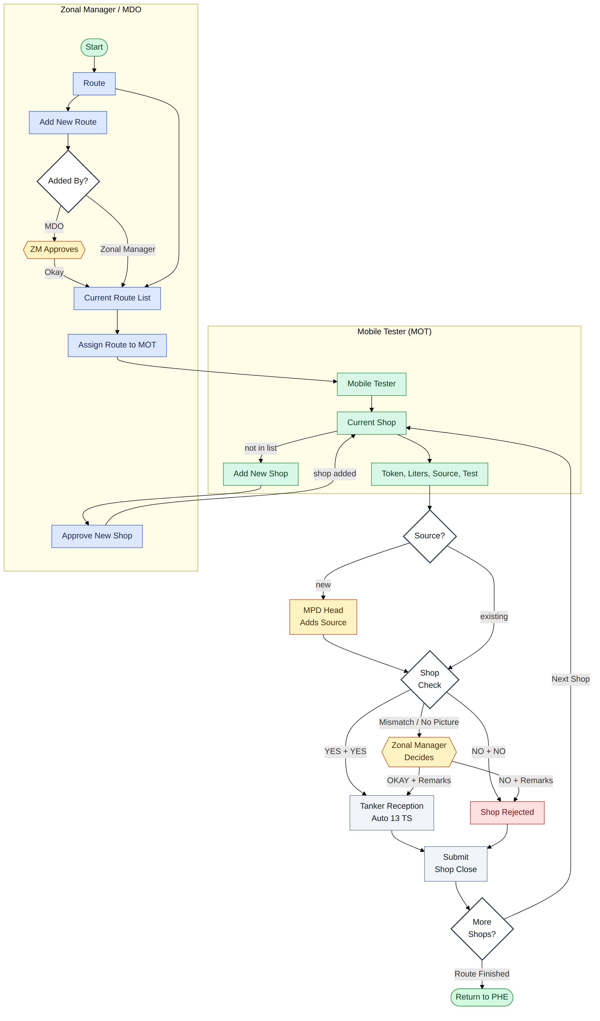
Figure 2: Stage 1 – Area Milk Collection

5. Stage 2 – HC/MC Reception at ZMCC

Users involved
- PHE Operator
- MDO
- Zonal Lab Attendant
- Zonal Manager
- MPD Head

Steps
- When the vehicle enters ZMCC, the PHE Operator issues the Raw Milk Token, either for the MC (Mobile Tester Collection) or for an HC.
- For an HC, the PHE Operator / MDO selects the HC from the list. If the HC is not in the list, they add the new HC information, and the Zonal Manager must approve it. Then the token is issued.
- The Zonal Lab Attendant tests the milk physically (with a picture where necessary).
- Composite: all tests are run on a single blended sample and recorded under one single portion.
- Portion-wise: tests are run separately for each compartment or batch and recorded under separate portions.
- Gives the Raw Milk Reception Token to the HC and selects the source name (as per SFPL ERP).
- Each portion is checked on its own:
- If the test follows the rule and he agrees, the portion is accepted.
- If the picture is missing or a value is against the rule, the portion goes to the Zonal Manager with remarks. OKAY means accepted; NO means rejected.
- If the rule says NO and he also says NO, the portion is rejected.
- If all portions are rejected, the vehicle is rejected and the journey is closed.
- Only accepted portions are weighed. For each one: First Weight, load to the ZMCC tank, then Second Weight. This is repeated for every accepted portion.
- Then the system calculates:
- the net weight, gross liters and 13 TS.
- the MOT loss/gain (Area loss/gain): the milk entered by the MOT is compared with the milk received and accepted at ZMCC.
- The accepted milk is added to the ZMCC tank. The journey is closed, and the Zonal Lab Attendant moves on to the dispatch to plant form.
- In case of MC rejection, the MPD Head writes remarks on what will be done with the milk.

Decisions and exceptions
- System YES and Lab Attendant YES: the portion is accepted and goes to weighing (First Weight).
- System NO and Lab Attendant NO (remarks needed): the portion is rejected. If all portions are rejected, the vehicle is rejected and the journey is closed.
- Mismatch, or test picture missing (remarks needed): the decision is sent to the Zonal Manager. OKAY with remarks accepts the portion (goes to weighing); NO with remarks rejects it.

Flowchart
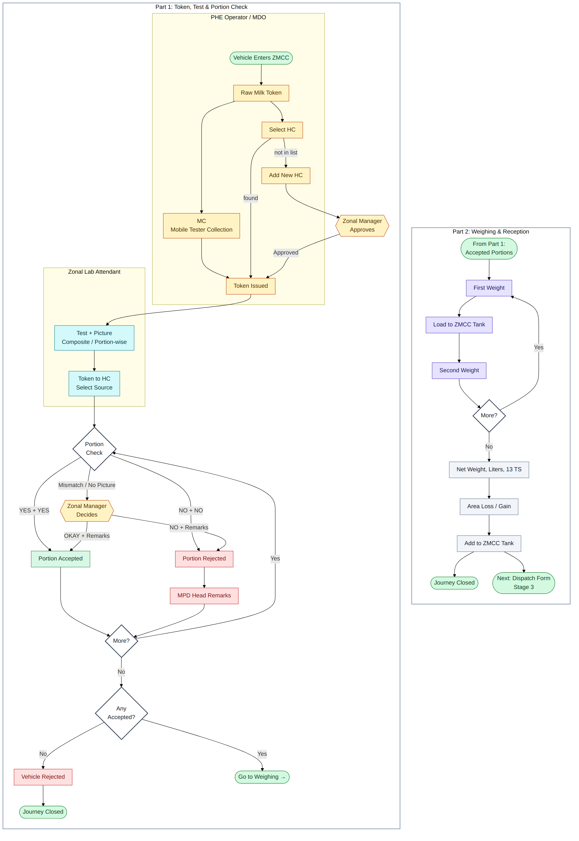
Figure 3: Stage 2 – HC/MC Reception at ZMCC

6. Stage 3 – ZMCC/Contractor Dispatch to Plant

Users involved
- Zonal Lab Attendant
- Contractor
- Zonal Manager

Steps
- The Zonal Lab Attendant opens the dispatch to plant form for the vehicle.
- Writes the vehicle number and the Raw Milk Dispatch Token.
- The Zonal Lab Attendant tests the milk:
- Composite: all tests are run on a single blended sample and recorded under one single portion.
- Portion-wise: tests are run separately for each compartment and recorded under separate portions.
- For each portion writes:
- the weight in kg
- the seal number
- the test result, with a picture where necessary
- the lab report picture
- The weight of every portion must be correct. A portion with more milk has more effect on the final result than a portion with less milk.
- If nothing is missed and all values follow the rule, click Submit and the vehicle is dispatched.
- If anything is missed, or any value is against the rule, click Send Request to Zonal Manager and writes remarks:
- If the Zonal Manager approves, the vehicle is dispatched.
- If the Zonal Manager does not approve, the vehicle is not dispatched and the Zonal Lab Attendant fills in the form again.
- A Contractor fills in the same details and presses Submit. Tests are not compulsory for a Contractor.
- After Submit, the system calculates the gross liters, the 13 TS and the milk remaining in the ZMCC tank.
- The vehicle then goes to the plant gate (Stage 4).

Decisions and exceptions
- The form gives two options: Submit and Send Request to Zonal Manager.
- Submit: when nothing is missed and all values follow the system rule, Submit dispatches the vehicle (Submit to Dispatch).
- Send Request to Zonal Manager (with remarks): when anything is missed or any value is against the system rule. The Zonal Manager answers Approved (the vehicle is dispatched to the plant) or NO with remarks (the vehicle is not dispatched; the Zonal Lab Attendant goes back to the dispatch to plant form and fills it in again).
- For a Contractor, tests are not compulsory.

Flowchart
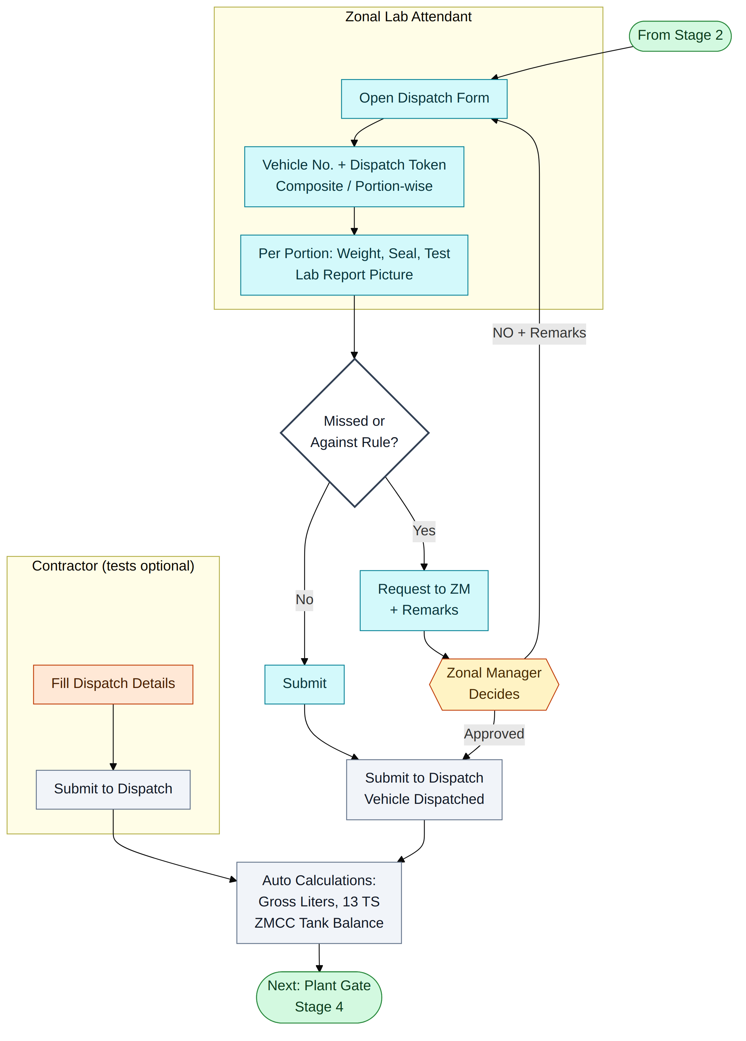
Figure 4: Stage 3 – ZMCC/Contractor Dispatch to Plant

7. Stage 4 – Plant Reception

Users involved
- Admin Operator
- QAE - Reception Lab
- AVP – Quality Assurance
- Weigh Bridge Operator
- Production Reception Operator

Steps
- At the gate, the Admin Operator issues the token.
- The QAE tests the milk:
- Composite: all tests are run on a single representative sample and recorded under one single portion (the QAE can also add test portions if compartments require independent testing).
- Portion-wise: tests are run separately for each compartment and recorded under separate portions.
- The QAE also checks that the seal numbers are the same as written at dispatch.
- Each portion is accepted or rejected:
- If the test follows the rule and the QAE agrees, the portion is accepted.
- If the picture is missing, a value is against the rule, or a seal number does not match, AVP – Quality Assurance decides.
- If the test is composite and it fails, the whole vehicle is rejected.
- Only accepted portions are weighed and unloaded to the silo. For each one: First Weight, unload, then Second Weight. For a composite test, this is done once for the whole vehicle. For a portion-wise test, it is repeated for every accepted portion.
- The Business Date is set once, at the first weight. Time from 00:00:00 (midnight) to 07:59:59 am gives the previous date; time from 08:00:00 am to 23:59:59 gives the current date.
- At the end, the system calculates the net weight, the gross liters, the 13 TS (a bigger portion counts more), the ZMCC loss/gain (dispatch compared with what the plant received), and the Transit loss/gain (what we purchased compared with what we received at the plant).
- When the Admin Operator clicks Gate Exit, the system first checks that the tanker is washed. Then the vehicle leaves and the journey is closed.
- For a rejected portion, the MPD Head writes remarks on what will be done with it.

Decisions and exceptions
- System YES and QAE YES: the portion is accepted and goes to weighing (First Weight).
- System NO and QAE NO (remarks needed): the portion is rejected. If all portions are rejected, the vehicle is rejected and goes to Gate Exit.
- Mismatch, test picture missing, or seal number not matching (remarks needed): the decision is sent to the AVP – Quality Assurance. Okay accepts the portion (goes to weighing); NO with remarks rejects it.
- If the test is composite and it fails, the whole vehicle is rejected, then Gate Exit.

Flowchart
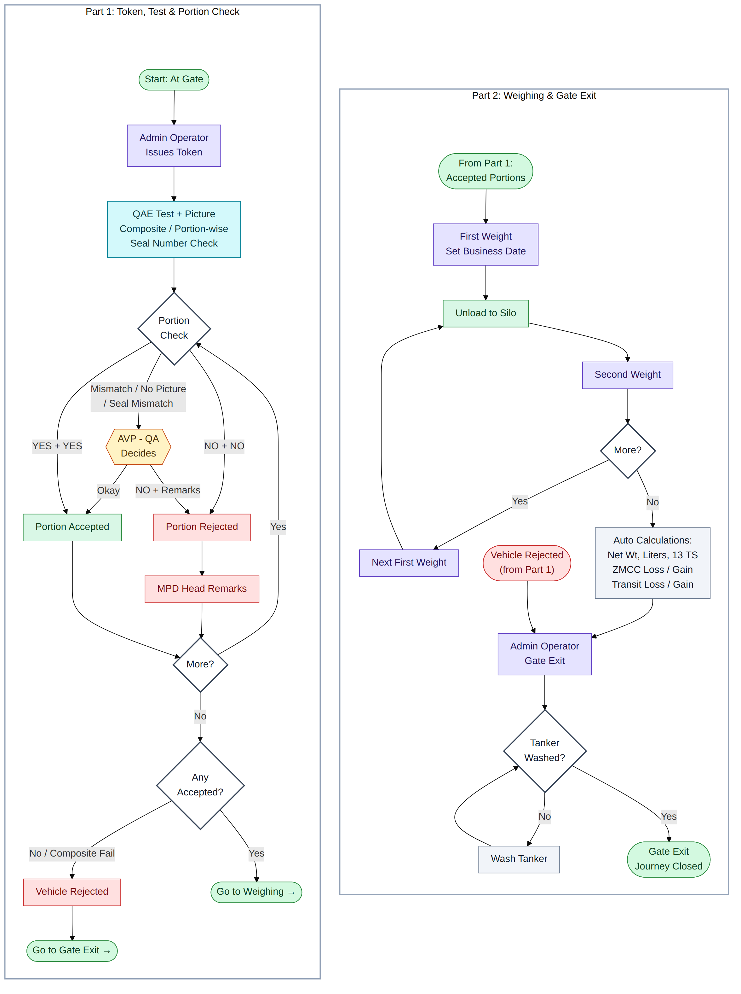
Figure 5: Stage 4 – Plant Reception

8. System Access and Support

System Support
- The complete web app runs online in any web browser, on a computer or mobile phone.
- It also works offline as an app on Android mobile phones.

Editing Access
- Only the Data Executive and the Super Admin can correct mistakes or make changes in the system.

9. Hierarchy
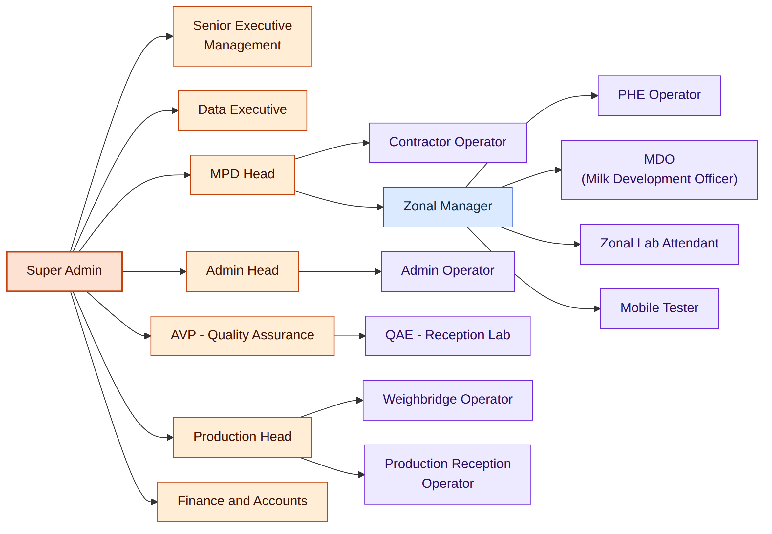
Figure 6: User Hierarchy

